KEYBOARD CABLE

- PARTS:

QUANTITY: PART #: NOMENCLATURE: LENGTH:

1 PER MACHINE 19274- CABLE, ROUND, 6-CON, 24 AWG 114 INCHES

1 PER MACHINE 18665- PLUG, DIN, 5-PINS N/A

1 PER MACHINE 18666- RECEPTACLE, DIN, 5-CON N/A

1 PER MACHINE 46034-2 TUBING, SHRINK, 1/16” BLACK 6 INCHES

- ASSEMBLY:

- 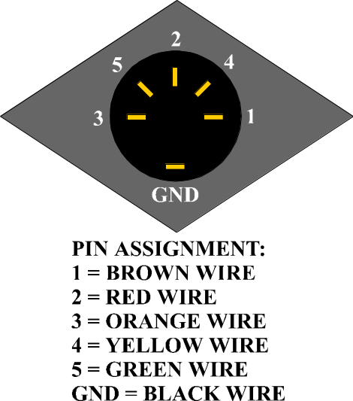ASSEMBLE THE RECEPTACLE ACCORDING TO DIAGRAM 1.

DIAGRAM 1

- SLIDE THE PLUG BOOT OVER THE CABLE.

C. ASSEMBLE THE PLUG ACCORDING TO DIAGRAM 2.

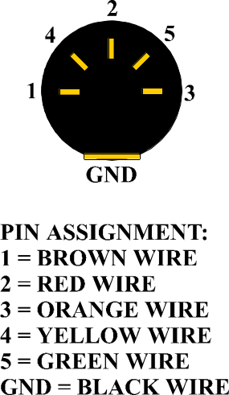

DIAGRAM 2

